Step Face Recognition

* Buat project baru

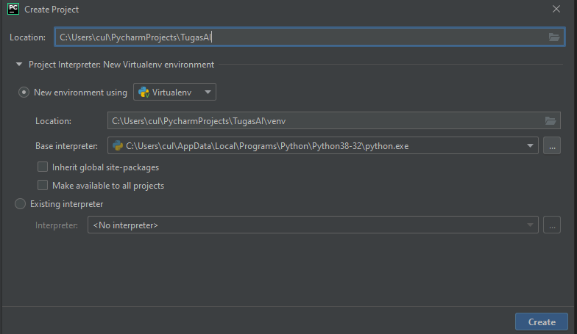

* Buat file baru dan copas codingan (code d paling akhir)

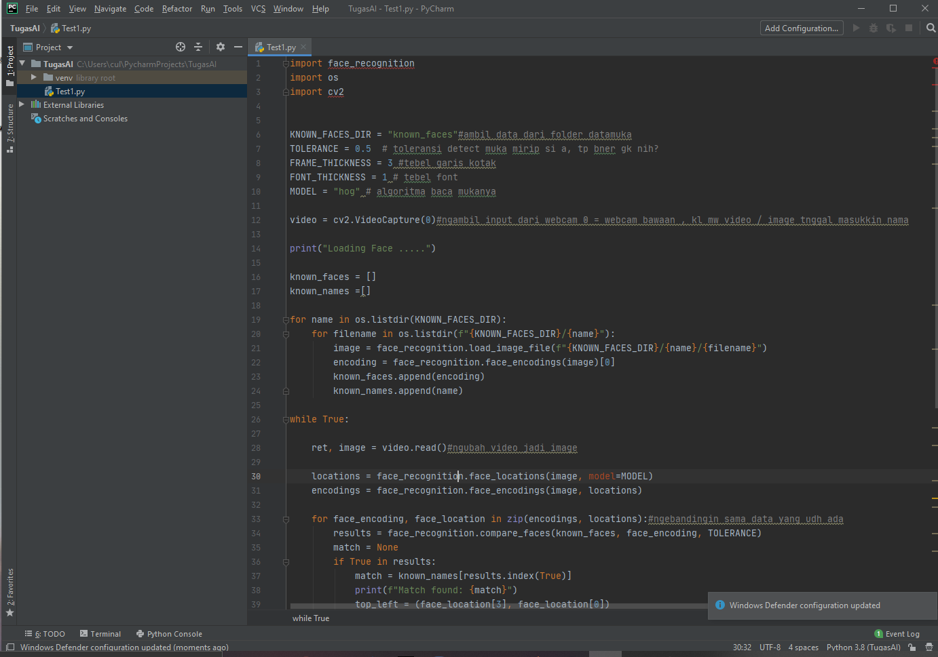

* Lalu install Package”nya ( File 🡪 setting 🡪 liat gambar)
  + Opencv-python
  + Face-recognition
  + Cmake
  + Dlib

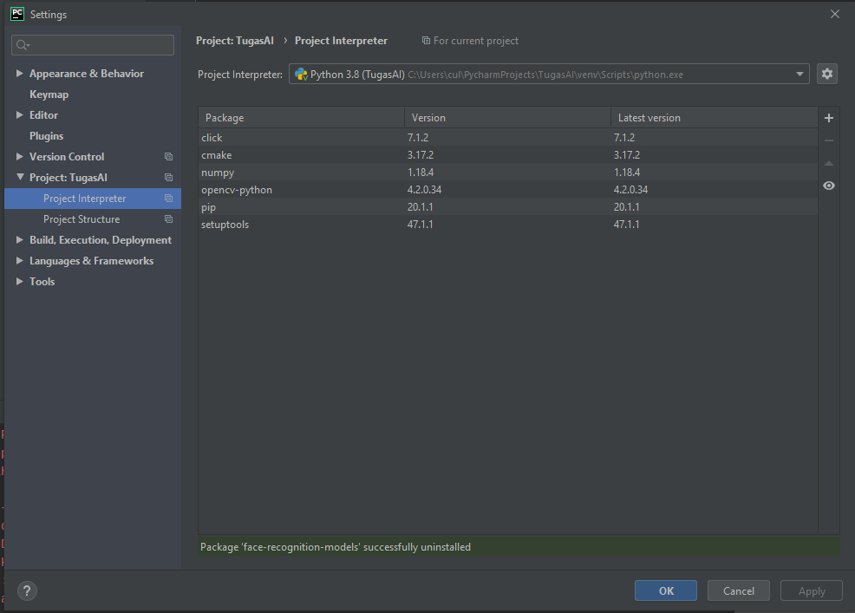

Notes : yang gua error terus gtw knpa pas install face-recognition sama dlib

* Kalau udah buka file projectnya d OS C; ( file project)

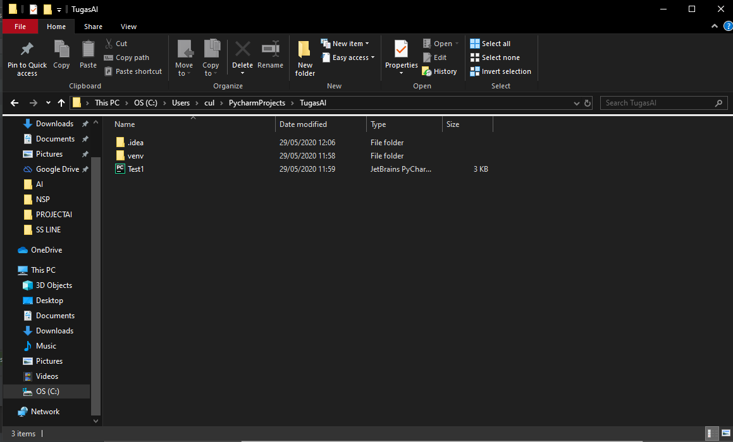

* Buat folder baru kasih nama known_faces karena sesuai yang ada d code dan buat folder data muka di dalam known_faces

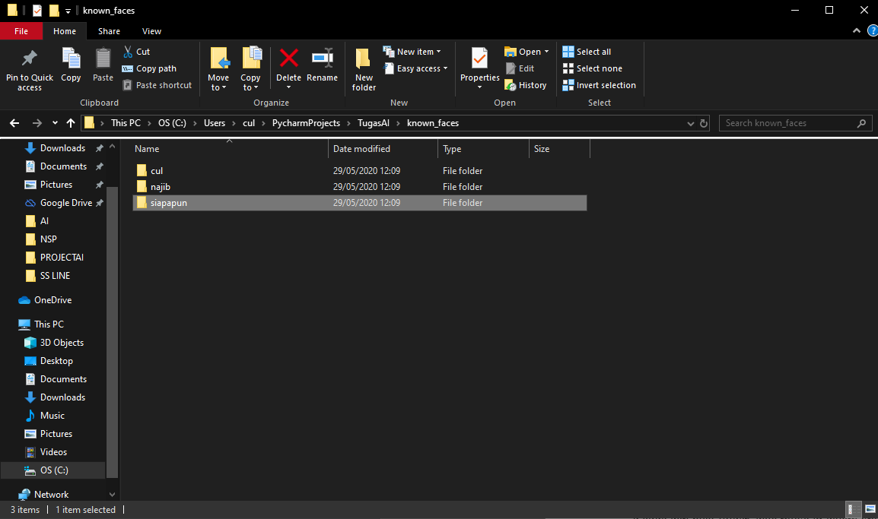

* Masukkin foto selfie di folder sesuai nama, lalu coba d run
* Codingannya

import face_recognition  
import os  
import cv2  
  
  
KNOWN_FACES_DIR = "known_faces"#ambil data dari folder datamuka  
TOLERANCE = 0.5 # toleransi detect muka mirip si a, tp bner gk nih?  
FRAME_THICKNESS = 3 #tebel garis kotak  
FONT_THICKNESS = 1 # tebel font  
MODEL = "hog" # algoritma baca mukanya  
  
video = cv2.VideoCapture(0)#ngambil input dari webcam 0 = webcam bawaan , kl mw video / image tnggal masukkin nama  
  
print("Loading Face .....")  
  
known_faces = []  
known_names =[]  
  
for name in os.listdir(KNOWN_FACES_DIR):  
 for filename in os.listdir(f"{KNOWN_FACES_DIR}/{name}"):  
 image = face_recognition.load_image_file(f"{KNOWN_FACES_DIR}/{name}/{filename}")  
 encoding = face_recognition.face_encodings(image)[0]  
 known_faces.append(encoding)  
 known_names.append(name)  
  
while True:  
  
 ret, image = video.read()#ngubah video jadi image  
  
 locations = face_recognition.face_locations(image, model=MODEL)  
 encodings = face_recognition.face_encodings(image, locations)  
  
 for face_encoding, face_location in zip(encodings, locations):#ngebandingin sama data yang udh ada  
 results = face_recognition.compare_faces(known_faces, face_encoding, TOLERANCE)  
 match = None  
 if True in results:  
 match = known_names[results.index(True)]  
 print(f"Match found: {match}")  
 top_left = (face_location[3], face_location[0])  
 bottom_right = (face_location[1], face_location[2])  
 color = [0, 255, 0]  
 cv2.rectangle(image, top_left, bottom_right, color, FRAME_THICKNESS)#buat kotak di daerah muka  
  
 #buat label nama  
 top_left = (face_location[3], face_location[2])  
 bottom_right = (face_location[1], face_location[2]+22)  
 cv2.rectangle(image, top_left, bottom_right, color, cv2.FILLED)  
 cv2.putText(image, str(match), (face_location[3]+10, face_location[2]+15), cv2.FONT_HERSHEY_SCRIPT_SIMPLEX, 1.0, (200,200,200),FONT_THICKNESS)  
  
 cv2.imshow(filename, image)#nampilin muka  
 if cv2.waitKey(1) & 0xFF ==ord("q"):#tombol exit dengan q  
 break  
  
#release holder di webcam laptop/computer  
video.release()  
cv2.destroyAllWindows()